NARROGIN SENIOR HIGH SCHOOL

YEAR 11 ECONOMICS

SEMESTER 1 EXAMINATION, 2007

NAME OF CANDIDATE ________________________

TIME ALLOWED FOR THIS PAPER
Reading Time: Ten Minutes
Working Time: 2 ½ Hours

MATERIAL REQUIRED/RECOMMENDED FOR THIS PAPER

TO BE PROVIDED BY THE SUPERVISOR
This Question / Answer booklet.
A separate Multiple Choice Answer Sheet.

TO BE PROVIDED BY THE CANDIDATE
Pens, pencils, eraser, ruler and calculator.

INSTRUCTIONS TO CANDIDATES
This paper has THREE (3) Sections.

SECTION A Attempt ALL questions (30 questions = 30 marks)
Answer ALL questions in Section A (Nos. 1-30) on the separate Multiple Choice answer Sheet.

SECTION B Attempt all Four (4) questions (4 questions = 30 marks)

SECTION C Attempt any Two (2) questions (2 questions = 30 marks)

Total for the paper – 90 marks

IMPORTANT NOTE TO CANDIDATES

No other items may be taken into the examination room. It is your responsibility to ensure that you do not have any unauthorised notes or other items of a non-personal nature in the examination room. Please check carefully and, if you have any unauthorised material with you, hand it to the supervisor BEFORE reading any further.

SECTION A – MULTIPLE CHOICE

Answer ALL questions on the answer sheet provided by a cross (X) over the correct choice. Choose the alternative which most correctly answers the questions or completes the statement.

- Different societies have evolved different methods of tackling the economic problem but while their methods are different, one ultimate aim appears to be the same. That aim is:

  - to make their country richer than all other countries
  - to make the best possible use of their resources
  - to achieve equality of incomes
  - to provide their consumers with the widest possible range of consumer goods and services

- A production possibility curve shows:

  - the alternative combinations of factors of production which an economy can use to produce a particular good
  - the change in a country’s rate of growth
  - the various alternative combinations of goods which an economy produces as it becomes more industrialised
  - the various alternative combinations of two goods or types of goods which an economy is capable of producing

- The opportunity cost of attending university is the:

  - cost of tuition fees, textbooks, and travel to university
  - cost to the Government of providing university education
  - income earned from employment instead of attending university
  - expenses involved in choosing alternative courses of study

- The decision as to how goods are produced in a market economy is made primarily by:

  - consumers in the market place
  - producers attempting to minimise costs
  - governments attempting to control production processes
  - financial institutions which provide the finance for investment

- Which of the following is not regarded as a determinant of supply?

- Technology
- Factor prices
- Buyer’s incomes
- Producers’ expectations

Questions 6 and 7 refer to the following diagram.

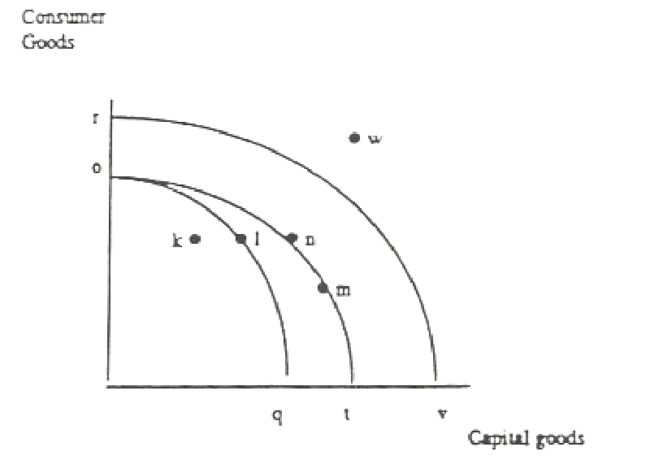

- A shift in the production possibilities curve from Oq to Ot may be caused by:

  - an increase in productivity for consumer goods
  - an overall improvement in productivity for both goods
  - an increase in productivity for capital goods
  - more of the existing resources being used to produce capital goods

- Given that other variables remain constant:

  - fewer consumer goods are produced at point n as compared to combination m
  - future economic growth is likely to be higher with combination m as compared to n
  - the current standard of living must be higher by producing at a combination m as compared to n
  - economic growth will move the economy to a more optimal combination m as compared to n

Question 8 refers to the following production possibilities schedule.

Combination | A | B | C | D | E
Food | 0 | 10 | 20 | 30 | 40
Textiles | 110 | 75 | 45 | 20 | 0

- Assuming the economy is operating at Combination B, the opportunity cost of producing an extra 10 units of food is:

  - 75 units of textiles
  - 30 units of textiles
  - 10 units of textiles
  - 45 units of textiles

- All of the following are held constant when deriving a producer’s supply curve except :

- the state of technology
- the preferences of producers
- the price of the commodity
- the prices of other commodities

- In the following figure, S1 and D1 represent the original supply and demand curves for a normal good, and S2 and D2 represent the new curves.

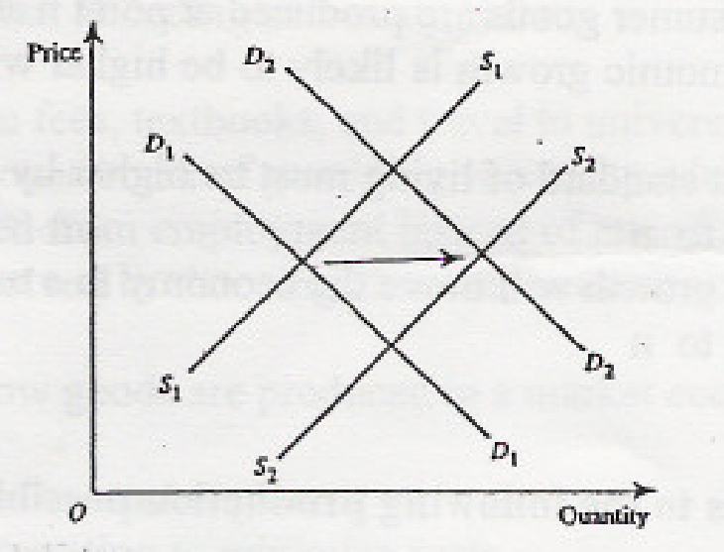

Which of the following combinations of events is most likely to have caused the movements of the demand and supply curves?

  - Changing consumer tastes and higher production costs
  - An increase in consumer incomes, and more efficient production techniques
  - Improved production techniques, and a fall in the price of a substitute product
  - A growing population, and an increase in sales taxes on the good

- According to the law of supply :

- price and quantity supplied are directly related
- price and quantity supplied are inversely related
- price falls will shift the market supply curve to the left
- price, factor availability and technology determine supply

- If quantity supplied exceeds quantity demanded then at a particular price:

- supply will shift to the right and price will fall.
- demand will shift to the left and price will fall.
- suppliers will cut back production and price will fall.
- buyers will compete for the surplus and price will rise.

- The simple circular flow demonstrates exchange between buyers and sellers in

  - the final product and factor markets
  - the real and money market
  - the resource and financial market
  - the real and final product market

14 If, in the Australian economy, investment is $160, saving $150, government expenditure $260, export receipts $130 and taxation $220, then to maintain equilibrium,

  - savings should be $210
  - imports should be $180
  - consumption should be $150
  - taxation should be $250

- If firms are producing $100 billion worth of goods and services, households are consuming $80 billion worth of goods and services, and firms want to invest $10 billion in a given year

  - savings are $20 billion and inventories are falling by $10 billion
  - savings are $20 billion and inventories are rising by $10 billion
  - savings are $10 billion and inventories are falling by $20 billion
  - savings are $10 billion and inventories are rising by $10 billion

16. Which of the following is an advantage of preference shares:

- they receive the largest dividends
- they have priority over ordinary shares for the payment of dividends
- they are the most actively traded share on the stock market
- if the company is liquidated, preference shareholders are certain to get their money back

  - In order to ‘list’ a company on the Australian Stock Exchange (ASX) it must:
- be of a sufficient size.
- agree to publish information that may affect the value of the shares.
- have binding contracts of the use of at least 80% of its float funds.
- guarantee future profitability.

18. The Australian Stock Exchange:

- buys and sells company shares on the stock market.
- administers the buying and selling of securities on the market.
- arranges the buying and selling of existing shares on the market.
- organises the buying and selling of new shares on the market.

19. The ‘par value’ of a share refers to:

- the market price of the share when it is sold by the shareholder.
- the value of the share compared to other shares on the market.
- the face value or nominal value of the share.
- the price of a share on a particular day of trading.

20. Which of the following best describes a primary market?

- a market that deals in new issue shares when they are first offered for sale.
- a market that deals in the buying and selling of existing shares.
- a market that deals in trading of both new and existing shares.
- a market that deals with the trading of shares at a price determined by market forces.

21. The price of shares in the secondary market is determined by :

  - the company issuing the shares.
  - the Australian Stock Exchange.
  - the market forces of demand and supply
  - the stockbroker.

22. A dividend is:

- the profit a person makes on the sale of a company share.
- that proportion of company profits paid to a shareholder
- the difference between par price and next sale price.
- the interest paid on the shareholders investment .in shares

23. Which of the statements about the all Ordinaries Index are correct?

- it measures movements in the aggregate market value of all shares in the index.
- it covers approximately 260 companies listed on the ASX, accounting for 90% of shares listed.
- it indicates the pre- tax return from shares after investing in dividend
- its base year value is 500.0

24. The main function of the financial market is to:

- make loans to consumers and firms.
- provide a link between savers and investors.
- charge interest on borrowed funds.
- ensure that there are sufficient funds for investment.

25. Which of the following types of assets would have the lowest expected return and the lowest risk?

- government bonds
- blue chip shares
- cash
- property

26. Diminishing returns can:

- be offset indefinitely in farm production by adding additional units of a variable factor of production
- be delayed by applying improved technology to farm production processes.
- be eliminated by increases in the fixed factor of production.
- only occur in non – farm production.

27. Government price support and stabilisation schemes in the farm sector:

- distort market signals resulting in a misallocation of resources.
- increase price to domestic consumers.
- cause overseas buyers to buy less
- (a) and (b)

28. An example of a farm input subsidy is:

- a direct payment to producers per unit of a commodity sold
- a tax rebate or concession on fuel used for farm purposes.
- A payment to farmers if income falls below a specified level.
- a payment to farmers who export part of their output.

29. The effects of production quota on the supply of milk are to:

- restrict total supply and raise prices from consumers.
- restrict total supply and encourage competition between milk suppliers.
- expand total supply and guarantee milk producers a share of the market.
- expand total supply and lower prices for consumers.

30. The main problem for Australian agriculture is:

- the capital to labour ratio is too high.
- there is insufficient productive land available for cultivation.
- protectionist policies of other governments.
- there are too many farms for the size of the Australian market.

  - 1 and 2
  - 2 and 3
  - 3 and 4
  - 1, 3 and 4

SECTION B: DATA INTERPRETATION

Answer ALL FOUR (4) questions 30 Marks

31.

Price $ |  | 2 | 4 | 6 | 8 | 10 | 12 | 14 | 16
Demand |  | 220 | 200 | 180 | 160 | 140 | 120 | 100 | 80
Supply |  | 20 | 50 | 80 | 110 | 140 | 170 | 200 | 230

(a) Graph the above table (3 marks)

Price
 | 16
 | 14
 | 12
 | 10
 | 8
 | 6
 | 4
Quantity | 2
 | 0
 |  |  |  | 40 |  | 80 |  | 120 |  | 160 |  | 200 |  | 240

(b) Indicate the equilibrium quantity. ____________________________________ (1 mark)

(c) At a price of $8, how much would be:

(i) demanded ________________ (ii) supplied? _________________ (1 mark)

(d) What is the equilibrium price? ________________ (1 mark)

(e) If the government supports a minimum price of $4, by how much does
demand exceed supply? _______________________________________ (1 mark)

(f) If the government controls price at a maximum of $14, by how much does
supply exceed demand? _________________________________________ (1 mark)

32. Examine the two models below showing a relationship between price (P) and quantity
supplied (Qs) in order to answer some of the questions below.

The Supply curves are shown as S1, S2, S3

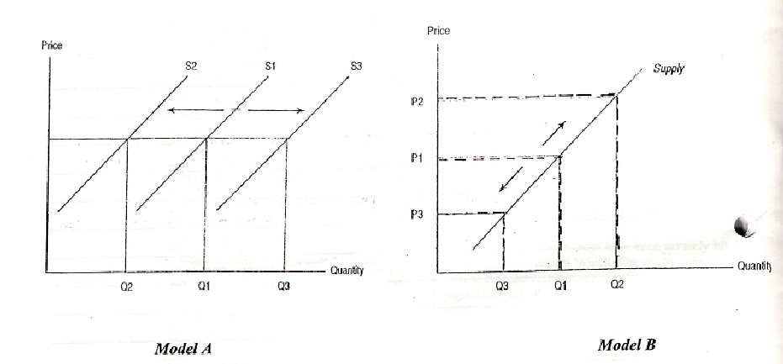

(a) Distinguish between individual supply and market supply. (2 marks)

(b) With reference to Model A and / or Model B describe the difference between extension
and contraction in supply and between increases and decreased in supply. (3 marks)

(c) Discuss the key factors that could be responsible for the movement of the supply curve
from S1 to S3 in Model A. (5 marks)

33. Study the following cartoon and then answer the questions that follow.

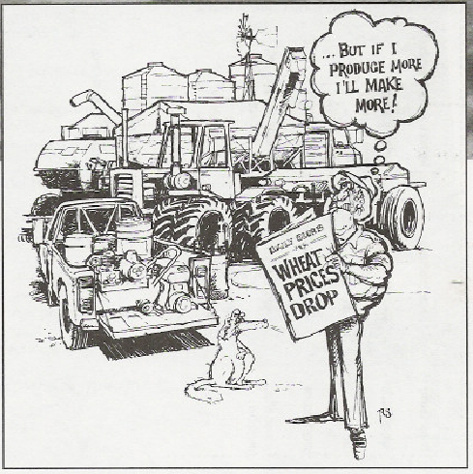

(a) What is the basic reasoning behind the farmer thinking ‘…..But if I produce more I’ll make more’. is this reasoning valid? (2 marks)

(b) What other actions could farmers in general take to overcome the price fall in wheat? (2 marks)

34. The figure given below shows movements in the All Ordinaries Index between 1999 and 2004.

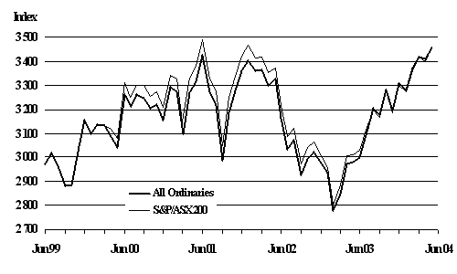

(a) What is the ‘All Ordinaries index’ ? (1 mark)

________________________________________________________________________________________________________________________________________________________________________________________________________________________________________________

(b) What was the ‘All Ordinaries index’ in June 2003? (1 mark)
________________________________________________________________________________

(c) To what extent is the ‘ All Ordinaries index’ useful to investors? (2 marks)
________________________________________________________________________________________________________________________________________________________________________________________________________________________________________________
________________________________________________________________________________

(d) Outline the factors that can cause movements in the ‘All Ordinaries index’. (4 marks)

SECTION C EXTENDED WRITING

Answer any Two questions – 30 marks

Suggested time for this section is 60 minutes

35. a) Distinguish between a “float” and “listing” on the Australian Stock Exchange
and describe the benefits to the company and to its shareholders of these
activities. [5 marks]

b) Distinguish between the major forms of returns that investors in the stock market
receive. [3 marks]

c) Describe the three major aims of investing and explain the advantages and
disadvantages of each aim. [7 marks]

36. a) Using a diagram of the simple circular flow model (that is, assuming no financial,
government or overseas sectors) explain why money flows in an economy. Explain
why Total Spending, Total Output and Total Income will always be equal in this
simple model. [6 marks]

b) Complete a diagram of the fully expanded circular flow model and explain what the diagram shows about the interaction of these sectors in the economy
[9 marks]

37. a) Explain, using diagrams, the operation of input subsidies and tariffs. [8 marks]

b) State and three benefits of the FarmBis program. [3 marks]

c) Who would gain from agricultural trade liberalisation and why? [4 marks]

Commence your answer to Section C on the lined pages which follow.

Commence your answer to Section C on this page. Clearly number the question you are answering.

